**3-2 Milestone Two: Enhancement One: Software Design and Engineering**

Christopher King

Southern New Hampshire University

CS-499 Computer Science Capstone 2024

Professor Conlan

November 17, 2024

**3-2 Milestone Two: Enhancement One: Software Design and Engineering**

* **Briefly describe the artifact. What is it? When was it created?**
  + The Rescue Animal app started as a Java-based project focused on managing rescue animals, including dogs and monkeys. It featured a Driver.java program to interact with the data via basic console inputs. The artifact has been transformed into a full-stack application using Node.js, Express, MongoDB, and Angular, enhancing its scalability and functionality. The original project was created during the IT-145 course, and the enhanced version was developed as part of the CS-499 capstone project.
* **Justify the inclusion of the artifact in your ePortfolio. Why did you select this item? What specific components of the artifact showcase your skills and abilities in software development? How was the artifact improved?**
  + The Rescue Animal app showcases my ability to design, develop, and enhance a complete software solution. It highlights skills in transitioning from standalone java application to a full-stack project, and implementing modular design and database integration.
  + Original Code Example: demonstrates fundamental programing skills including object instantiation and array list management

* + Enhanced Code Example: This schema illustrates my ability to define and implement database models using MongoDB

* + This artifact was enhanced by replacing Java data structures with NoSQL database for better scalability, adding RESTful APIs for seamless data integration, and incorporating modern design principles in the front-end and back-end.
* **Did you meet the course outcomes you planned to meet with this enhancement in Module One? Do you have any updates to your outcome-coverage plans?**
  + Yes, the enhancements aligned with several course outcomes such as transitioning to a modular full-stack architecture (Designing and evaluating computing solutions), and the integration of MongoDB and RESTful APIs demonstrates the use of industry-specific tools (Using innovative techniques). I plan to focus on extending security measures in this application, such as adding authentication and authorization, to further align with the security focused outcome.
* **Reflect on the process of enhancing and modifying the artifact. What did you learn as you were creating it and improving it? What challenges did you face?**
  + As I was enhancing and modifying the artifact, I realized that organization and a roadmap of how the artifact would be enhanced is essential. In the beginning, I was updating all sections at once and not focusing on a specific aspect of the application. This lead to some confusion on my part and I had to go back and re-organize the components in a more efficient way. I also did not comment as I was working, so I had to go back and input all/most of my comments. I plan to complete this as I move forward so there is less confusion and so I do not have to go back and complete it.

**Screenshots:**

**Original Menu**

**Enhanced Menu**

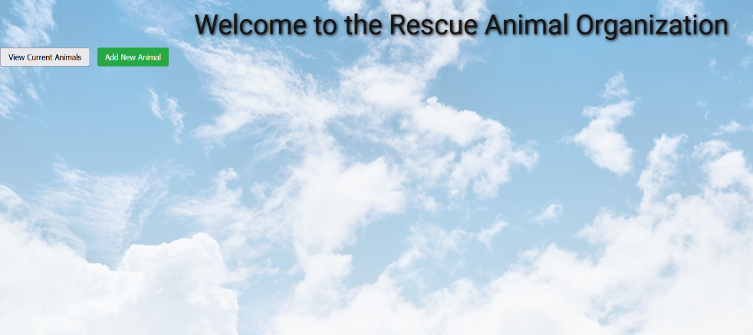

**Original Intake**

**Enhanced Intake**

**Original List**

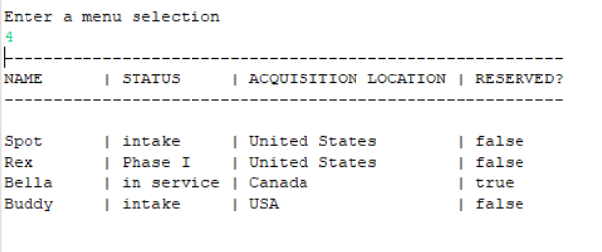

**Enhanced List**

